Chapter 5
System Design and GUI

5.1 Designing

Designing has become one of the most compelling and attractive strategies of the web in the present era. Interface of the site (i.e. Appearance of input and output screen) should be easy to navigate as well as attractive so that the user couldn't resist entering and visiting the specific site.
To cope with the requirements and trends of the world we have also paid our attention on the designing of my site.

5.2 Graphical User Interface (GUI) Design

GUI of the system is very simple yet discrete. It allows the user to grasp as much information as possible on a single page without scrolling but in the cases of lists the pages are to be scrolled. Pagination is also use in some cases so as to give the user a hustle free environment.

User participation is very important at every stage of development process, particularly for the design of the user interface. The term user, in this case, refers not only to the primary or operational user but also to all other users who require the results of the operation for their processes. The bottom line is that for application modeling, the user's screen in an important element.

5.3 Symfony Template Usage Overview

5.3.1 Code Design

We have Symfony 1.2 for creating the dynamic web page. The code written in PHP 5.0 consists of two parts.
- The HTML portion of the page serves two functions. It captures input data for transmission to the server, and it displays output results from server processing. These two functions take place through Web Forms containing various server controls, special form elements that permit data input, output display, and requests for script processing.
- The SCRIPT portion of the page, normally coded at the top of the page, contains server code to process data. That data can be supplied by the user through a form, extracted from files or databases, or generated internally by the script. The script contains processing commands, or statements, written in Java Scripts which are encapsulated within named subroutines, or subprograms, that are called upon to perform their processing.

5.3.2 Web Site Layout Design:

The alternative PHP syntax is preferable for templates to make them readable for non-PHP developers. PHP code is kept to a minimum in templates, since these files are the ones used to design the GUI of the application. Keeping the logic inside the action also makes it easier to have several templates for a single action, without any code duplication.

The <html>and <body> tags are stored in a file called layout.php, which contains the page layout. This file, also called the global template, stores the HTML code that is common to all pages of the application to avoid repeating it in every template. The content of the template is integrated into the layout, or, if you change the point of view, the layout “decorates” the template.

5.4 User Interface

5.4.1 Home Page

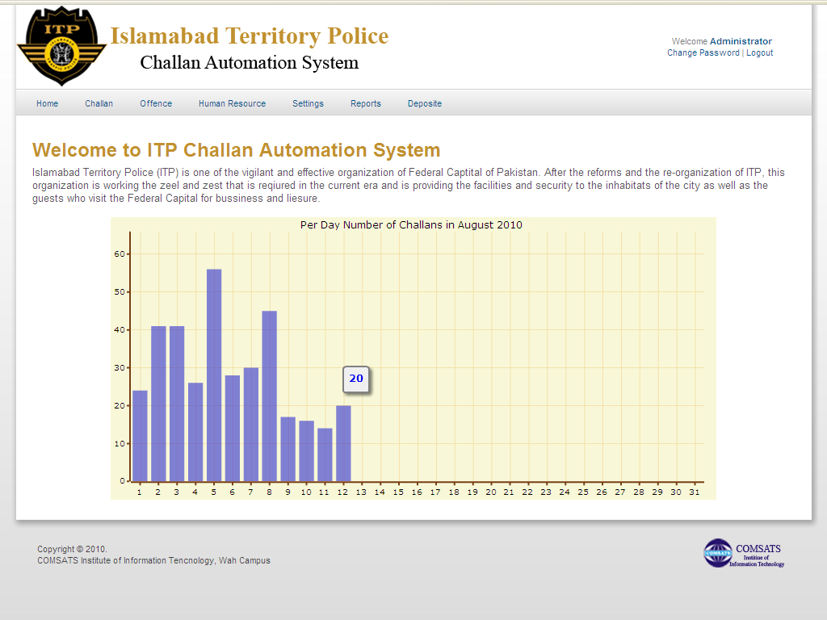
This is the dashboard of the users who are authenticated and redirected here.
Figure 5.1 Home Page

5.4.2 User/Employee Registration and Listing Pages

User interface shows User Registration page Screen
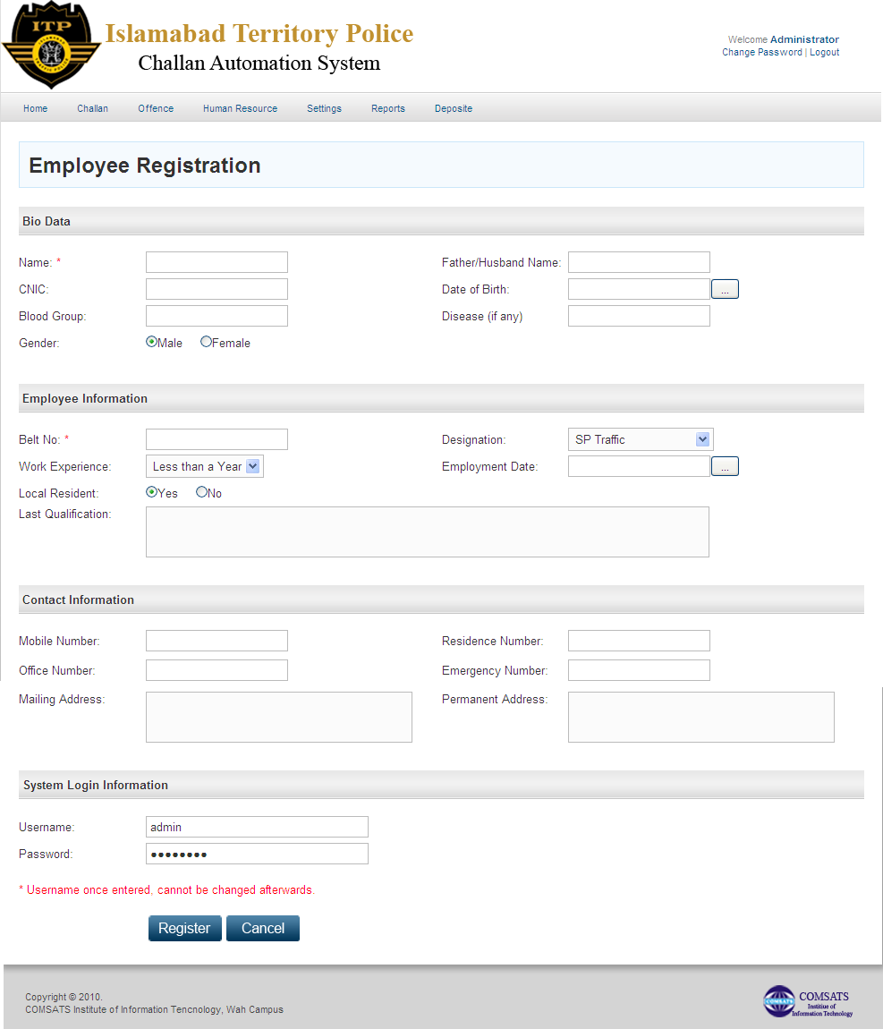
Figure 5.2 User/Employee Registration Page
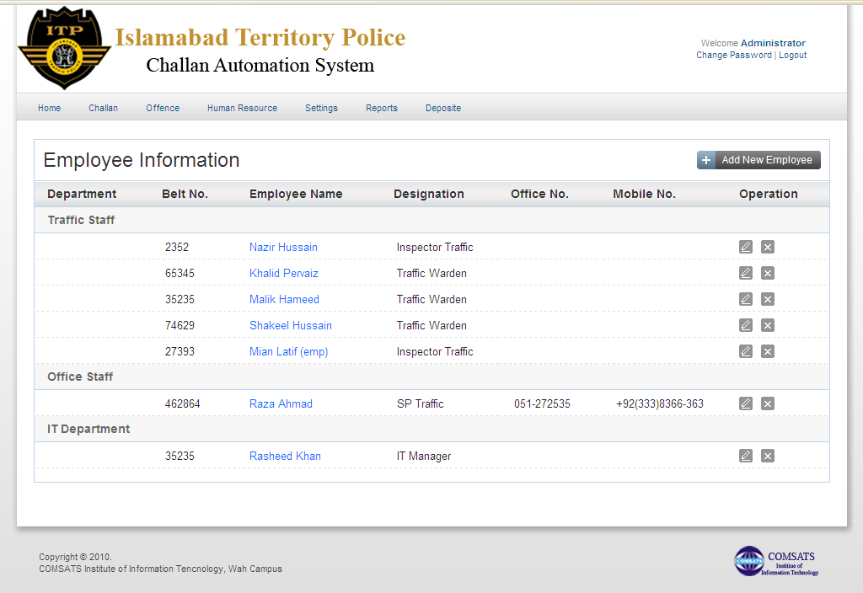
Figure 5.3 User/Employee Listing Page

5.4.3 User Account Page
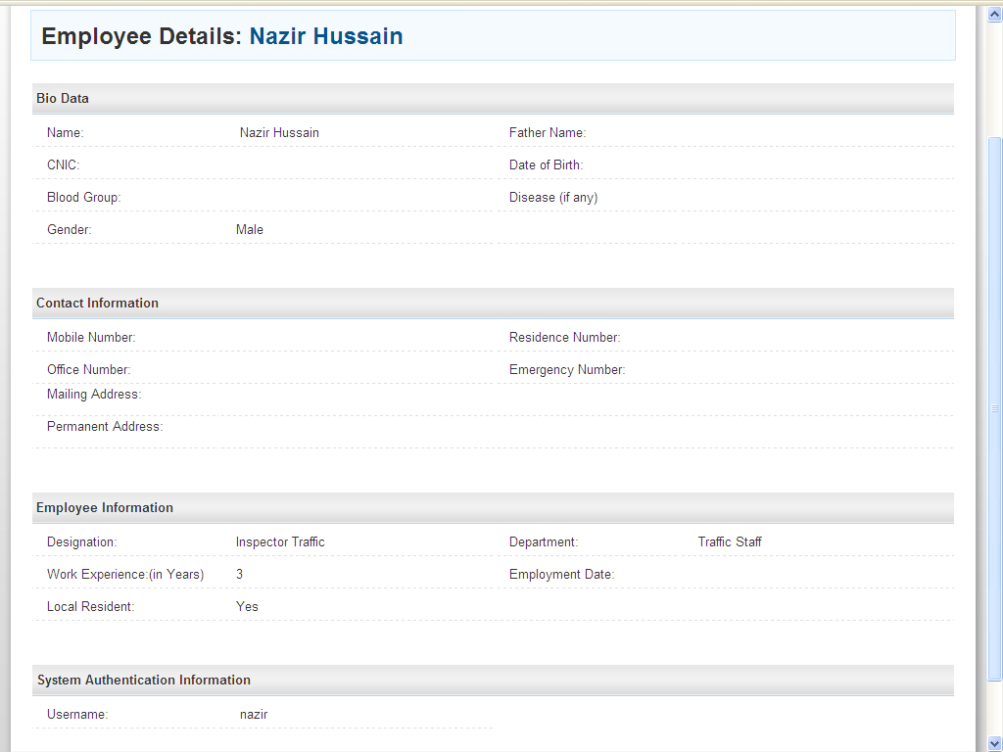
Figure 5.4 User Registration Page
5.4.4 Daily Challan Listing Page

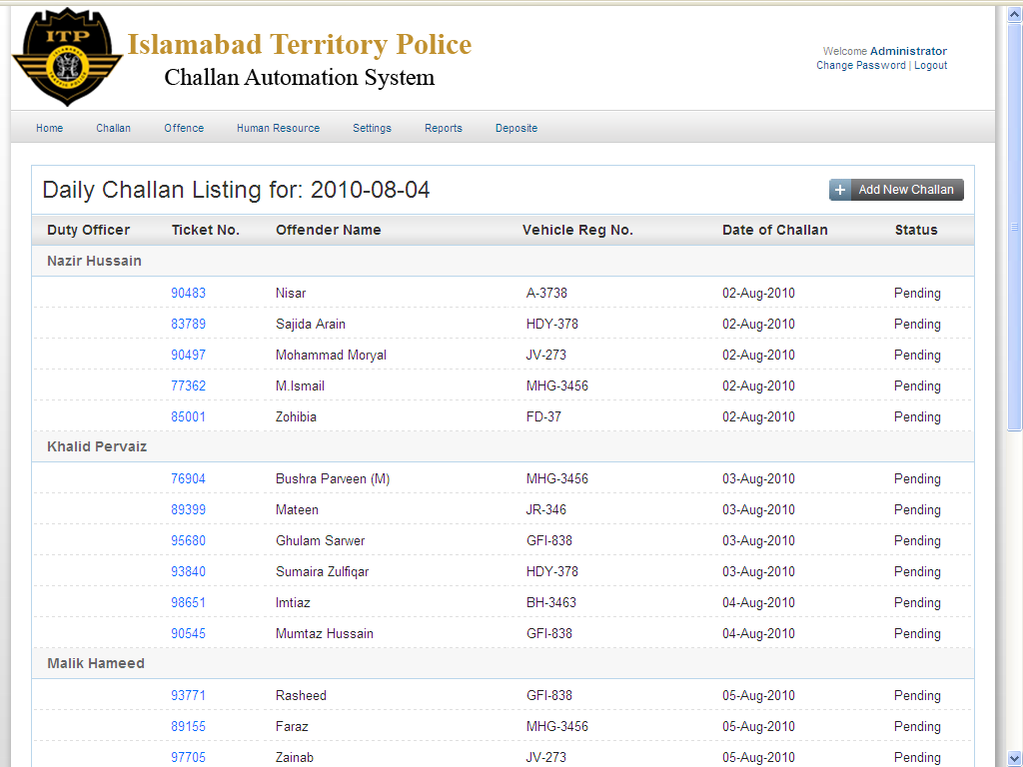
Figure 5.5 Daily Challan Listing page

5.4.5 Challan Detail page

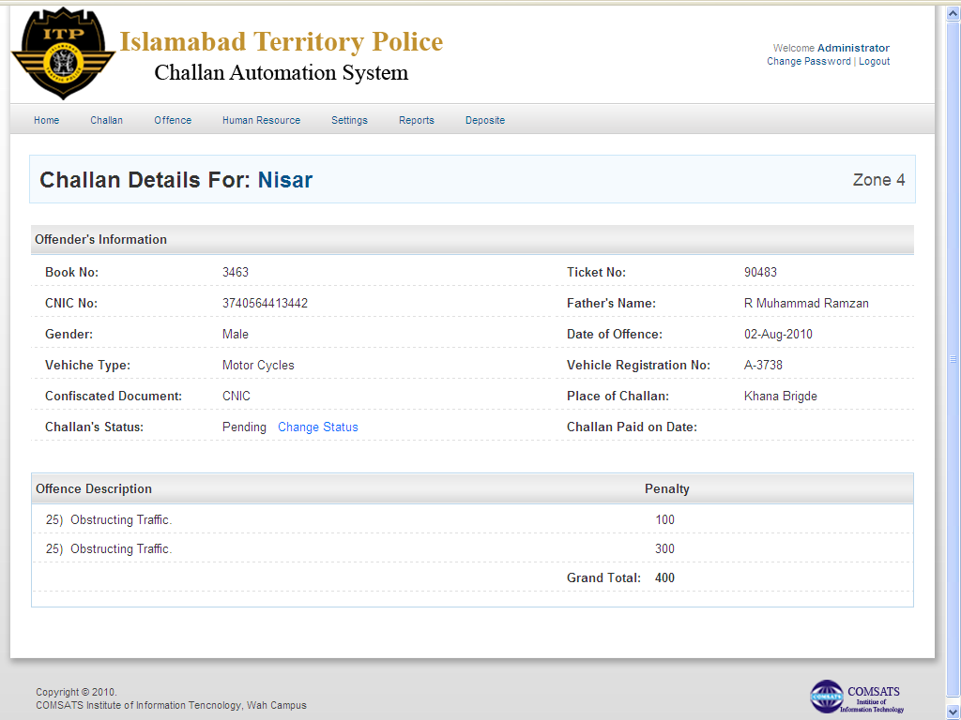

Figure 5.6 Challan Detail page

5.4.6 Pop up for the Add Function

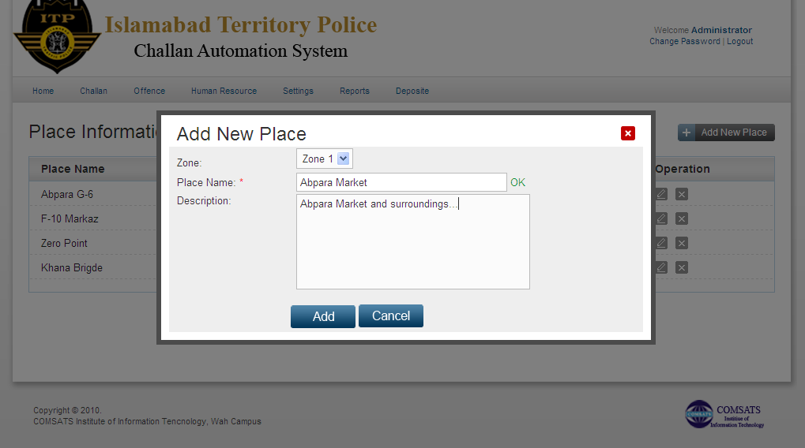
Figure 5.7 Pop Up Screen

5.4.7 Listing of the Reports
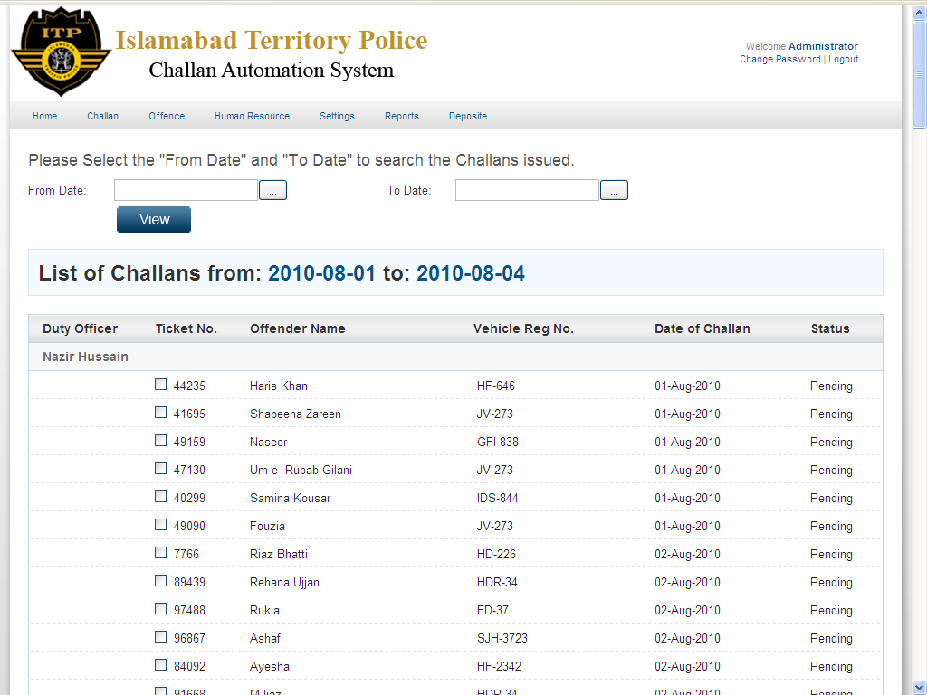
Figure 5.8 Listing of Reports

